 |  |  |  |  |  |  |  |  |  |  |  |  |  |  |  | Tree nuts
Last name |  |  | First name | Role  (staff or student) | Milk (dairy) | Egg | Fish | Crustacean | Mollusc | Sesame | Lupin | Peanut | Soy | Wheat | Gluten | Almond | Brazil nut | Cashew | Hazelnut | Macadamia | Pecan | Pine nut | Pistachio | Walnut | Other allergies/ dietary requirements
 |  |  |  |  |  |  |  |  |  |  |  | 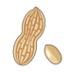 |  | 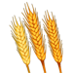 |  | 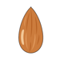 |  |  | 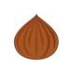 |  | 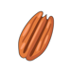 |  | 